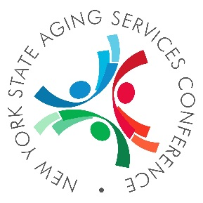
NEW YORK STATE AGING SERVICES CONFERENCE
Embassy Suites by Hilton, Syracuse Destiny USA, 311 Hiawatha Blvd. W, Syracuse NY 13204
October 3 - 4, 2019
2019 Conference Registration Form
View Complete Schedule and Register Online: nysaging2019.eventbrite.com
ATTENDEE INFORMATION
NAME:
AGENCY & COUNTY:
ADDRESS:
CITY, STATE, ZIP:
PHONE:
EMAIL:
MEMBER OF (Please check only one)
☐ ASDNYS ☐ NYSANASP ☐ MOWNYS ☐ NOEP ☐ OTHER
CONFERENCE OPTIONS
Option 1 – Full conference: All Training Sessions, Two Breakfasts, Two Lunches - $140
Option 2 – One-Day Conference (THURSDAY): Training Sessions, Breakfast & Lunch - $100
Option 3 – One-Day Conference (FRIDAY): Training Sessions, Breakfast & Lunch - $90
Option 4 – Student One-Day Conference (THURSDAY): Training Sessions, Breakfast & Lunch, Dinner - $50
Option 5 – Student One-Day Conference (FRIDAY): Training Sessions, Breakfast & Lunch - $45
TOTAL DUE
Please indicate dietary restrictions you have for the meals included in your registration:
☐Gluten-free ☐Lactose-free ☐Nut allergy ☐Vegetarian ☐Other _________________________
Conference Registration Deadline is September 6, 2019
(Please add late fee of $10.00 if postmarked after 9/6)
PAYMENT INFORMATION
☐Cash Enclosed | ☐Check Enclosed | ☐Credit Info Below
Card Number: |  |  | Expiration:

RETURN COMPLETED FORM AND PAYMENT TO:
Meals on Wheels New York State
c/o David Smith
Meals on Wheels NYS
144 Cedar Street
Corning, NY 14830
(607) 962-7985

LODGING: Discounted room blocks are available at the Embassy Suites, Syracuse Destiny USA through September 2, 2019. Please reference Meals on Wheels- HFW2-BBGQJ4 when making your reservation. If you are a tax-exempt organization, please be sure to provide your tax-exempt form when checking in at the conference.

ROOMS $129 per night

CALL (315)-303-1650 or BOOK ONLINE: https://bit.ly/2W0jqWn

